Project Design Phase-II
Technology Stack (Architecture & Stack)

Date | 28 steptember 2026
Team ID | SWTID-2026-3622
Project Name | Import Data using Transform Maps
Maximum Marks | 4 Marks

- Technical Architecture (Text-Based Flow Diagram):

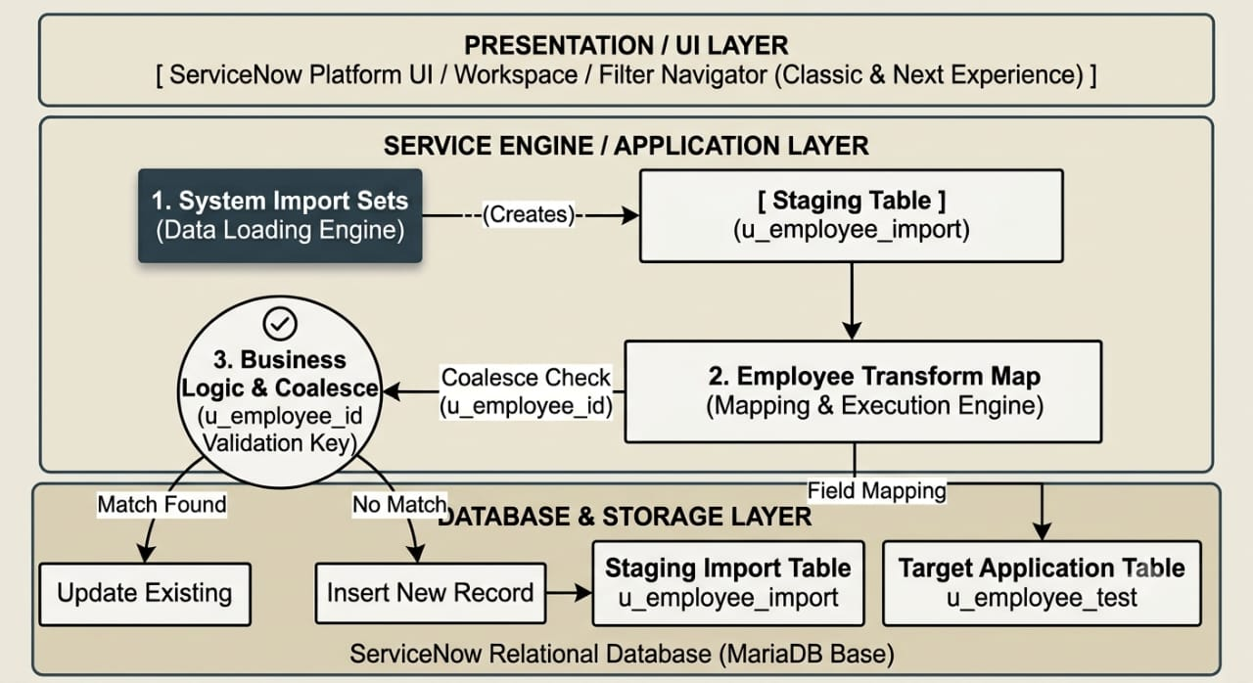

2.Table-1: Components & Technologies:

S.No | Component | Description | Technology
1. | User Interface | Platform administration interface used to upload files, map fields, and monitor import status | ServiceNow Polaris / Next Experience UI (HTML5, CSS3, JavaScript, Jelly).
2. | Application Logic-1 | Staging Engine (System Import Sets) that processes uploaded files and constructs the temporary import table | ServiceNow Server-Side Glide API & Import Set Subsystem.
3. | Application Logic-2 | Transformation Engine (Transform Map) executing auto-field matching and data casting. | ServiceNow Transform Engine / JavaScript (Rhino Engine).
4. | Application Logic-3 | Coalesce Logic checking existing target rows against u_employee_id to perform insert vs. update branching. | ServiceNow Data Scrubbing & Coalesce Engine.
5. | Database | Multi-tenant relational schema housing custom tables (u_employee_import and u_employee_test). | ServiceNow Instance Database Engine (MariaDB-backed relational store).
6. | Cloud Database | High-availability cloud-hosted database underlying the ServiceNow instance. | ServiceNow Advanced High Availability (AHA) Cloud Infrastructure.
7. | File Storage | Staging repository for raw .xlsx file attachments prior to parsing. | ServiceNow Attachment Table (sys_attachment) / Instance Cloud Storage
8. | External API-1 | Ingestion interface allowing programmatic spreadsheet submission. | ServiceNow Table API / Import Set REST API.
9. | External API-2 | Authentication layer ensuring secure administrative session access. | OAuth 2.0 / Multi-Factor Authentication (MFA).
10. | Machine Learning Model | N/A (Rule-based deterministic field mapping used instead). | Native Auto-Map Matching Algorithm
11. | Infrastructure | Multi-instance enterprise cloud architecture hosted on ServiceNow infrastructure | Cloud Infrastructure (ServiceNow Personal Developer Instance - PDI / Hosted Cloud).

- Table-2: Application Characteristics:

S.No | Characteristics | Description | Technology
1. | Open-Source Frameworks | Native JavaScript libraries utilized for data parsing and browser UI rendering | JavaScript (ECMAScript), Apache POI (underlying Excel parser engine).
2. | Security Implementations | Access restricted strictly to authorized roles (admin, import_admin) controlling staging table read/write permissions. | Role-Based Access Control (RBAC), Access Control Lists (ACLs), TLS 1.3 Encryption in transit
3. | Scalable Architecture | Enterprise 3-tier architecture isolating client browser, app server nodes, and dedicated database clusters. | ServiceNow Multi-Node Cloud Architecture (Application Nodes + DB Replica)
4. | Availability | Instance redundancy ensured across primary and secondary data center pairs. | ServiceNow Advanced High Availability (AHA) Architecture with automated failover.
5. | Performance | Asynchronous batch transformation handling row insertions in memory prior to bulk committing | ServiceNow Import Set Batch Processing & In-Memory Transformation Engine.

